15 Runtime Controller



This section will guide you to understand:

* How to perform runtime controller

**Development Environment:**

* Apache JMeter 5.1.1 Version
* JDK Runtime Environment 11.0.2

This guide has four subsections, namely:

1.15.1 Recording scripts

1.15.2 Adding runtime controller

1.15.3 Running the scripts in runtime controller

1.15.4 Pushing the code to your GitHub repositories

**Step 1.15.1:** Recording scripts

* Open JMeter.
* Right click on Test Plan.
* Click on Thread(Users) -> Thread Group.

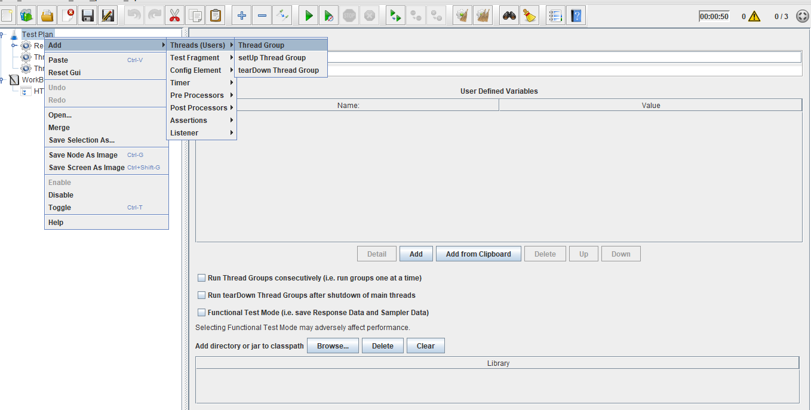

* Right click on Work Bench.
* Click on Add -> Non Test Elements ->HTTP(s) Test Script Recorder.

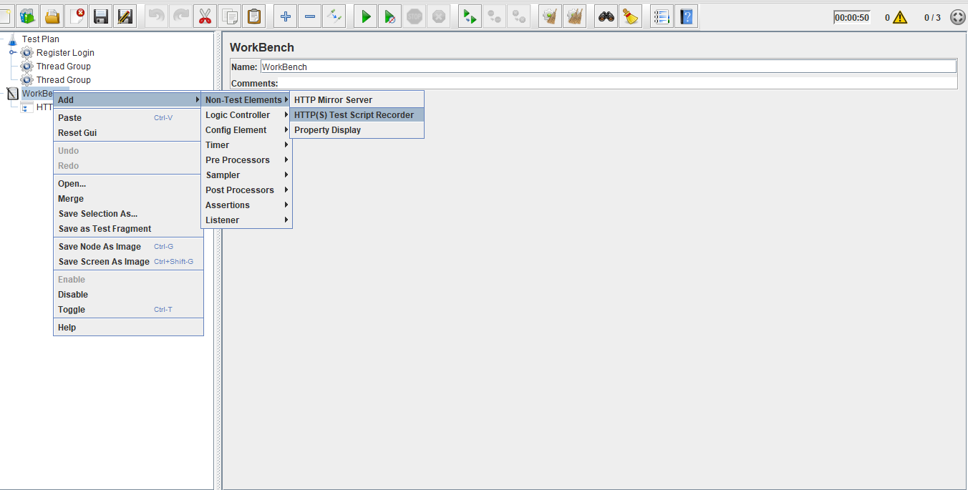

* Right click on Thread Group.
* Click on Add -> Logic Controller->Recording Controller.

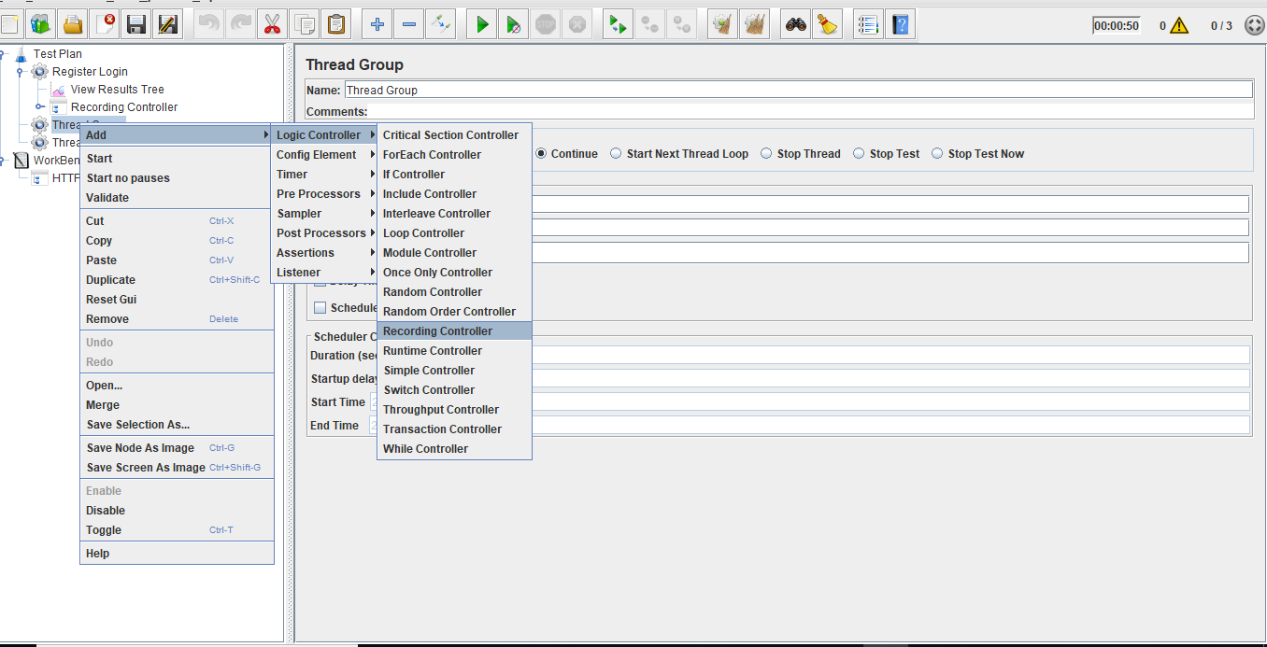

* Right click on Thread Group.
* Click on Add -> Listener->View Result in Tree.

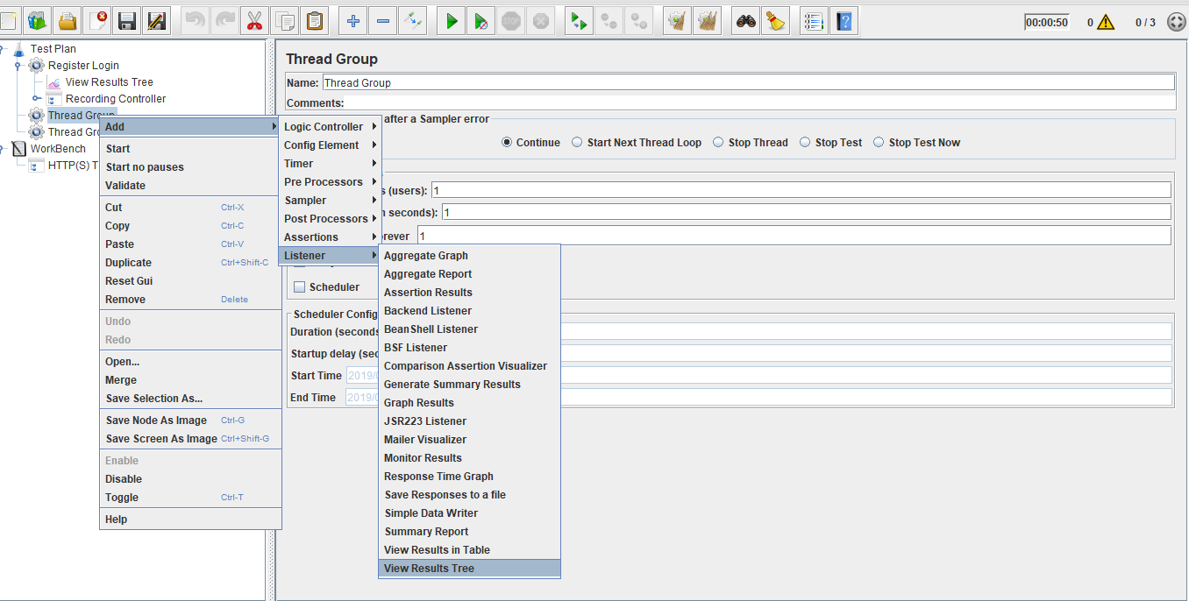

* Configure proxy settings in the browser.
* Run the scripts.
* Automatically JMeter records the scripts.

**Step 1.15.2:** Adding runtime controller

* Right click on Thread Group.
* Click on Add -> Logic Controller -> Runtime Controller.

### 

**Step 1.15.3:**  Running the scripts in runtime controller

* Recording scripts should be added as child scripts for the runtime controller.
* Provide the runtime and run the scripts.

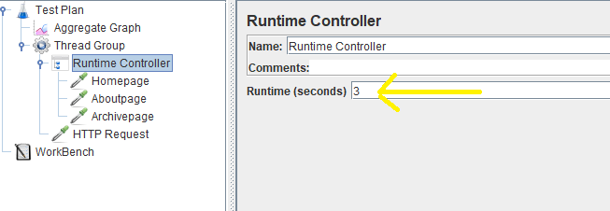

* Run the throughput controller and view the results as below:

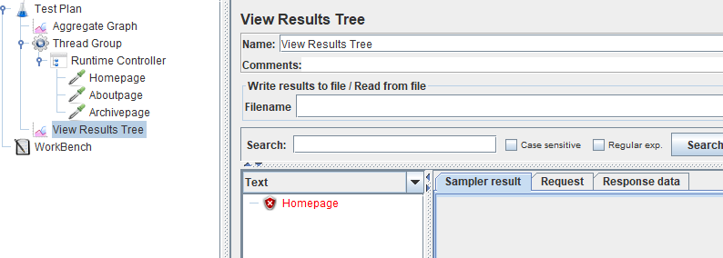

* **Note:** Number of running scripts will depend on runtime.

**Step 1.15.4:** Pushing the code to GitHub repositories

Open your command prompt and navigate to the folder where you have created your files.

cd <folder path>

Initialize your repository using the following command:

git init

Add all the files to your git repository using the following command:

git add . 

Commit the changes using the following command:

git commit . -m “Changes have been committed.”

Push the files to the folder you initially created using the following command:

git push -u origin master